Table 1: Wine Quality Model Experiment Results

|  |  |  |
| --- | --- | --- |
| Attributes | Accuracy [%] | AUC |
| All Attributes | 98.70% | 0.99 |
| Fixed Acidity - Free Sulphur Dioxide | 83.80% | 0.74 |
| Volatile Acidity - Total Sulphur Dioxide | 94.50% | 0.92 |
| Citric Acid - Sulphates | 85.30% | 0.76 |
| Residual Sugar - Ph | 81.90% | 0.76 |
| Chlorides - Alcohol | 94.20% | 0.92 |
| Density | 77.80% | 0.65 |

1. What is the percentage of correct classification results (using all attributes)?

The accuracy is 98.70 % when all attributes are selected. The AUC is 0.99.

1. What is the percentage of correct classification results (using a subset of the attributes of your choosing)?

Results are showed in the above table. Accuracy for All Attributes, Fixed Acidity + Free Sulphur Dioxide, Volatile Acidity + Total Sulphur Dioxide, Citric Acid + Sulphates, Residual Sugar + Ph, Chlorides + Alcohol, and Density are 98.70%, 83.80%, 94.50%, 85.30%, 81.90%, 94.20%, and 77.80% respectively.

1. What is the AUC of your model (all features vs feature subset)?

Results are showed in above table. AUC for All Attributes, Fixed Acidity + Free Sulphur Dioxide, Volatile Acidity + Total Sulphur Dioxide, Citric Acid + Sulphates, Residual Sugar + Ph, Chlorides + Alcohol, and Density are 0.99, 0.74, 0.92, 0.76, 0.76, 0.92, and 0.65 respectively.

1. Visualize your decision tree

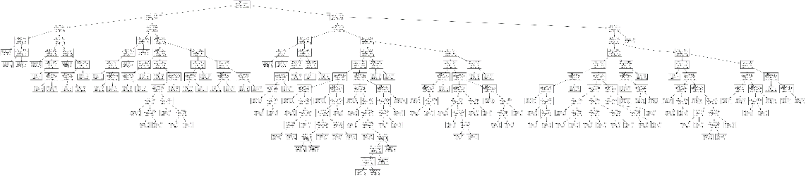

1. What is your best AUC that you can achieve?

The highest AUC was 1 when all the attributes were selected for the predictions. AUCs for lesser trials/experimental models are showed in table 1.

1. Which attributes are mostly informative for this prediction test? How did you identify them?

The highest accuracy (94.50%) and AUC values (0.92) were obtained when the Volatile Acidity and Total Sulphur Dioxide attributes were selected comparing with other subsets of attributes from table 1. Using the subset of attributes of Chlorides and Alcohol results in the second highest accuracy (94.20%) and highest AUC values (0.92).

Volatile Acidity, Total Sulphur Dioxide, Chlorides, and Alcohol are mostly informative.